Lê Duy Khang

MSSV : 1711020104

Class :17DTHQA2

Final Report :

Smart Fire System

1. What is Smart Fire ?
2. Introduction
3. Purpose
4. Product Scope
5. Design
6. Scrum Board
7. UML Class Diagram
8. Database Diagram
9. GUI (Graphical User Interface )
10. Overall Description
11. . User Class and Characteristic
12. . Product Funtions
13. System Feature
14. Detect Fire
15. Get notified when there's a fire
16. System structure diagram
17. Stimulus /Response Sequences
18. Functional Requirements
19. Update personal safety status
20. See status of loved one upon receiving fire notification

Task

1. Smart Fire
2. Introduction

* Smart Escape is an early detection and warning system for high-rise buildings. It can notify users about emergency situations when a fire occurs, as well as monitor the victim's location inside a fire and provide information on the escape directions in a building. In addition, the system also provides data, information on victims, the situation of continuous fire for the management to devise appropriate responses.

1. Purpose

* Early detection and warning of a fire.
* Provide surveillance, follow up the situation and rescue victims quickly.
* Minimize loss of life and property.

1. Product Scope

* Smart Escape can be used together with surveillance cameras installed in buildings, apartments, hotels, shops, etc., where fire incidents can be detected as quickly as possible, to reduce minimal damage.

1. Design
2. Scrum board

What is scrum board ?

* A Scrum Board is a tool that helps Teams make Sprint Backlog items visible. The board can take many physical and virtual forms but it performs the same function regardless of how it looks.
* Scrum events consist of the following:

•Sprint

•Sprint Planning

•Daily Scrum

•Sprint Review

•Sprint Retrospective

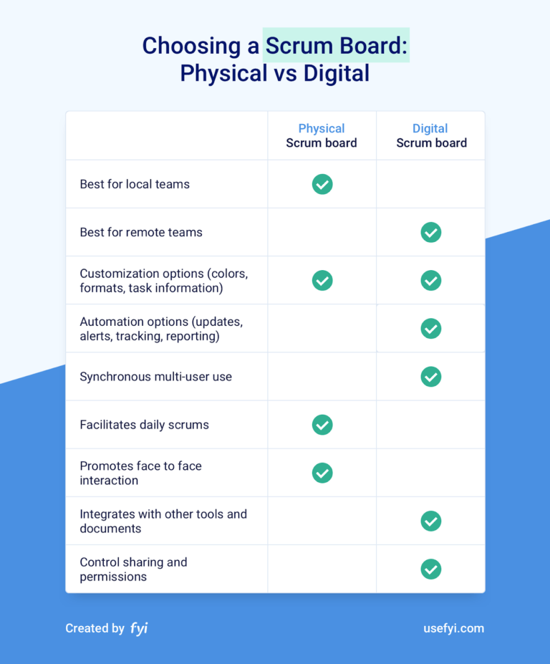

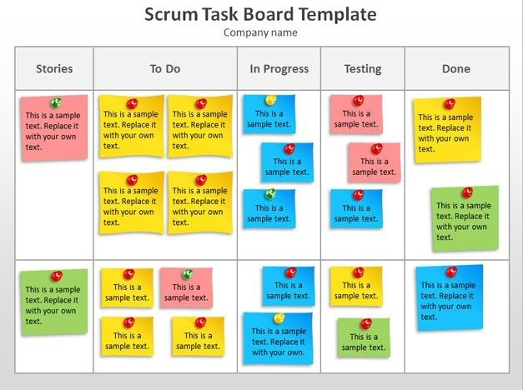

1. UML Class Diagram

What is UML Class Diagram

* The UML Class diagram is a graphical notation used to construct and visualize object oriented systems. A class diagram in the Unified Modeling Language (UML) is a type of static structure diagram that describes the structure of a system by showing the system's:
  + - classes,
    - their attributes,
    - operations (or methods),
    - and the relationships among objects.

1. 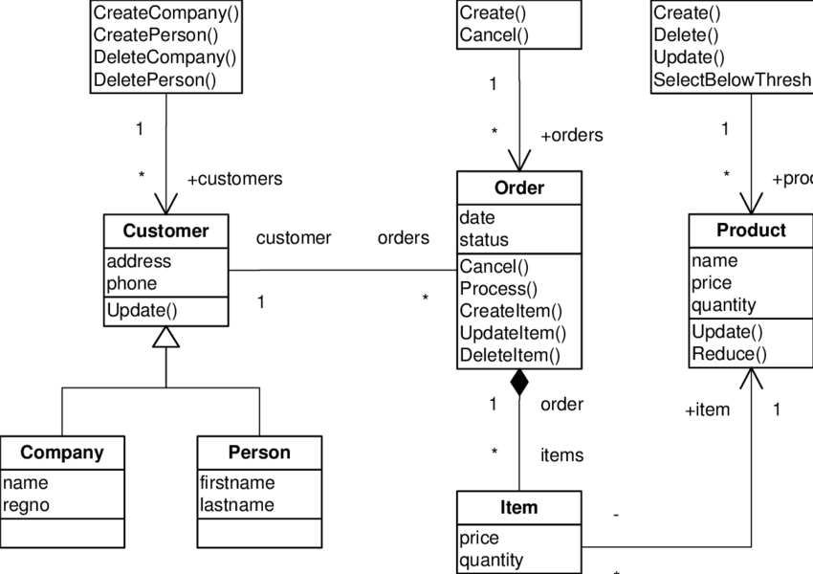Database Diagram

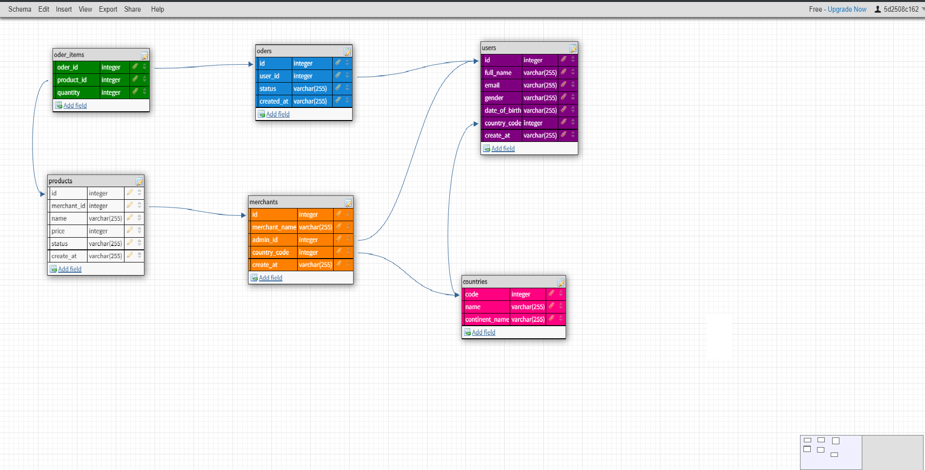

1. GUI (Graphical User Interface )

What is a GUI (Graphical User Interface )?

* A GUI (graphical user interface) is a system of interactive visual components for computer software. A GUI displays objects that convey information, and represent actions that can be taken by the user. The objects change color, size, or visibility when the user interacts with them.
* GUI objects include icons, cursors, and buttons. These graphical elements are sometimes enhanced with sounds, or visual effects like transparency and drop shadows.

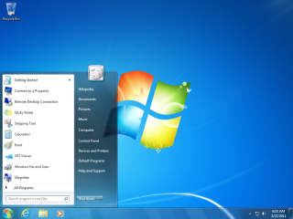

* Login :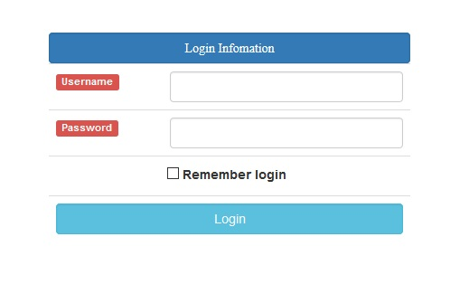
* Create Account: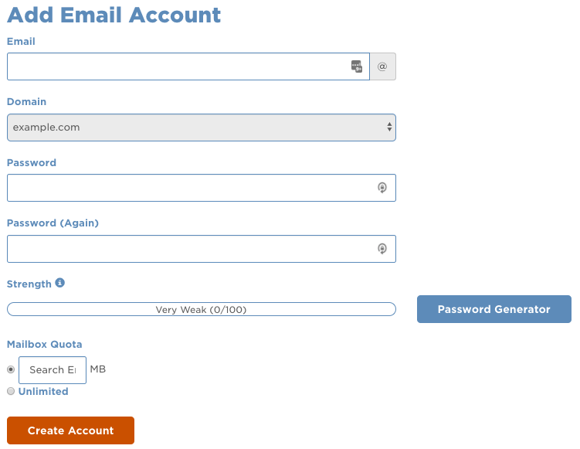

1. Overall Description
2. User Class and Characteristic

* User class:

• System management and monitoring department.

• Normal users.

1. Product Funtions

* On the management side:

• Receive alerts on fire locations on installed cameras.

• Send notifications to all users within the area of a fire.

• Monitoring and statistics of the status and number of people in the area where a fire occurs.

• Notify fire protection team

* On the user side:

• Receive fire alerts from management.

• Update your own safety status as required when a fire occurs.

• See safe exits in a fire area to escape.

• See current status of loved ones when there is a fire warning.

• Provide photos, update fire situation for management.

• Temporary fire extinguishing if possible.

1. System Feature :
2. Detect Fire
3. Get notified when there's a fire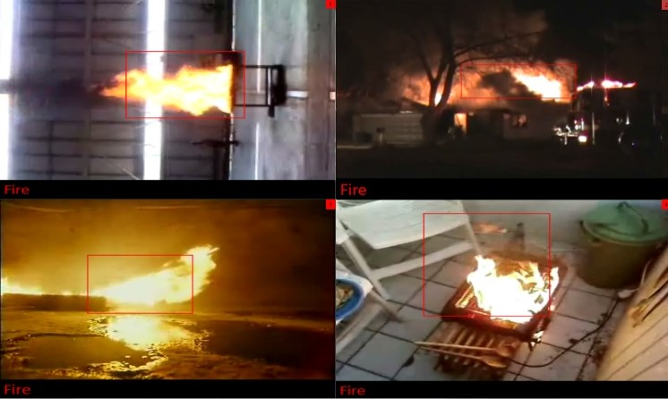

* For manager:

When fire appears in the scope of surveillance cameras, the system will pick up images and analyze them. If the predicted result is a fire, the system will send an image of the location, location and time of the fire to the manager.

* For customer:

After the manager has confirmed that a fire has occurred and needs a warning, the system will send a notice to all customers within the building that are burning, and ask everyone to update the safety status, Current position of each individual.

1. System structure diagram:

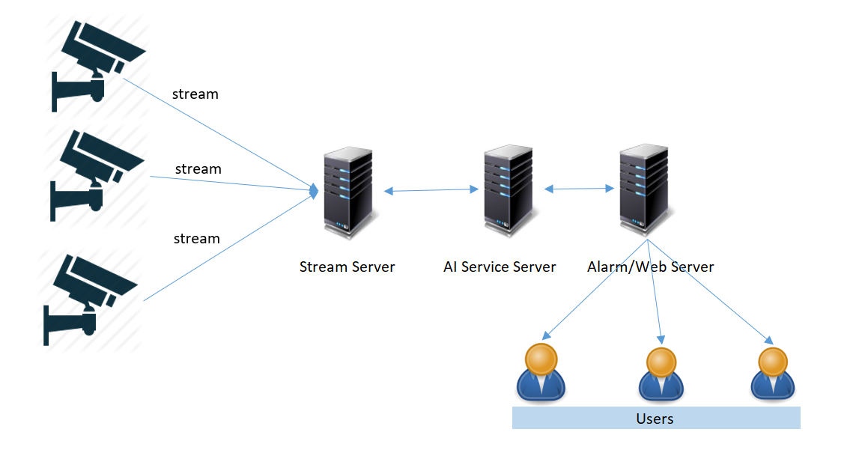

1. Stimulus /Response Sequences

For manager application:

* Alarm, Notification

- Can download 1 app (Android / iOS) to listen / receive alarm information

- When a fire is detected, the device of the manager will receive an alarm from the phone with pictures and clips at the fire detection camera

- In addition to the [Alarm] function, there are also functions:

* Call [Call]: to call directly to the fire-fighting telephone numbers of these emergency numbers already set up such as: 114, ...
* [Dismiss]: To cancel the notification, when canceling need to store User information, press the [Dismiss] button.
* [Live]: Can connect to the camera that is already on fire to be able to monitor the current status.
* [View]: Can watch clips from detect fire to 30 seconds (this time can be set at system configuration) after burning.

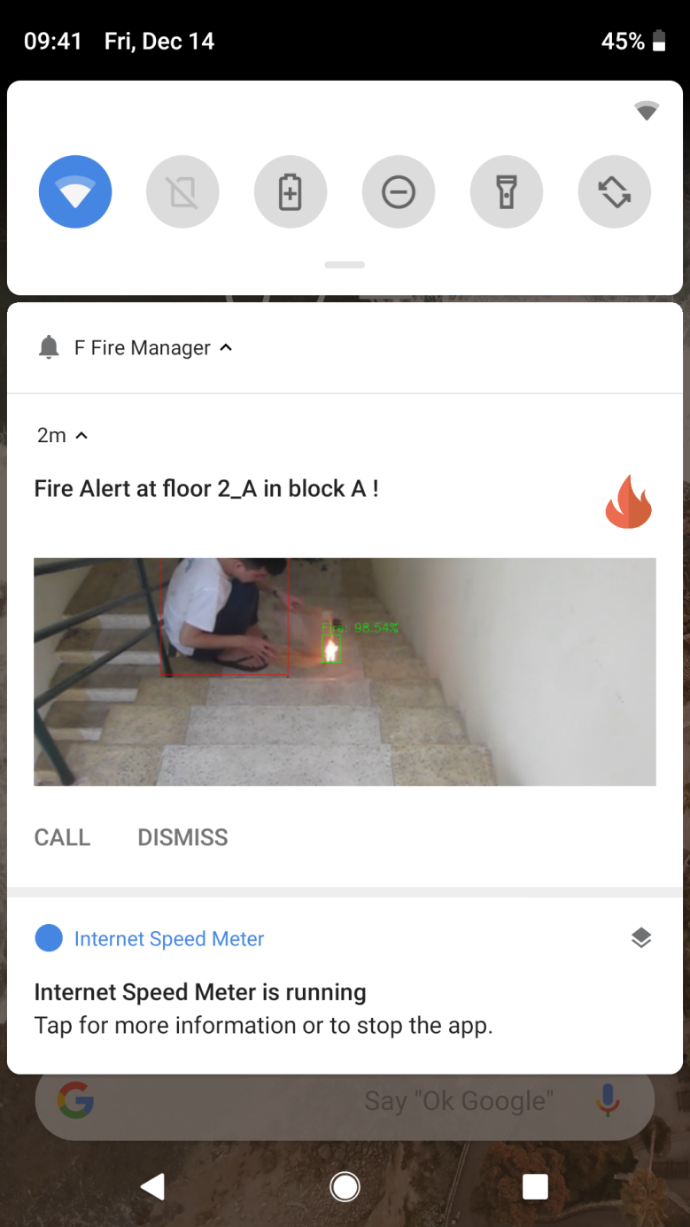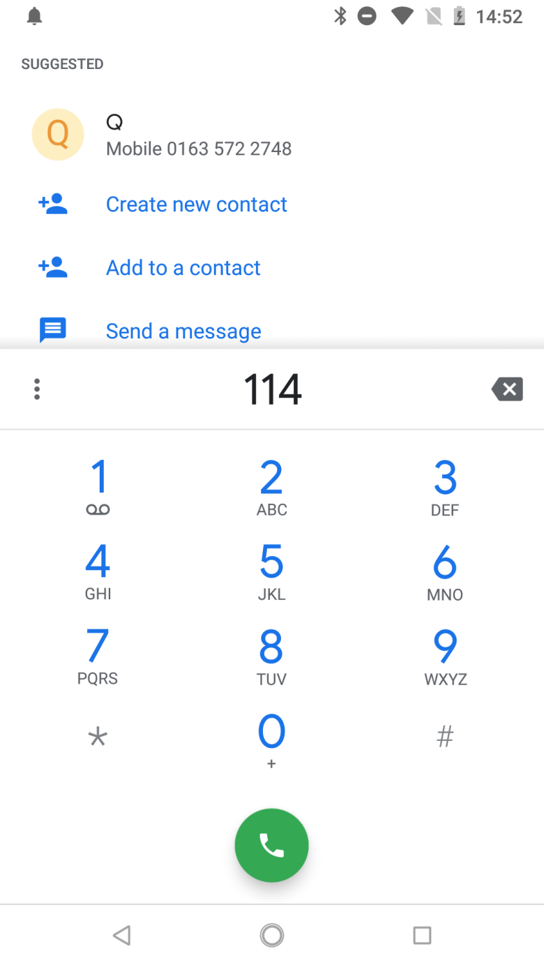

When clicking on the notification will open the application and automatically go to the camera view screen where the fire was detected (Figure 3).

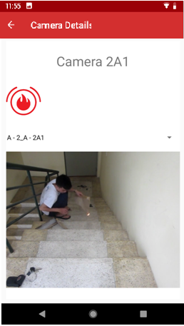

Figure 3 Manager application - when clicking on notification

For customer app:

When there is a fire notification, the device will ring a warning and the app screen will boot up:

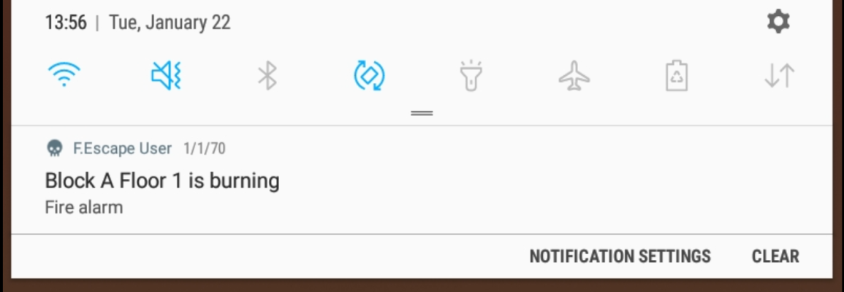

Figure 4: Customer application

1. Functional Requirements

REQ-1: The user must login to the system

REQ-2: The user devices must be online

1. Update personal safety status

* Description
* This function is only available in the customer app, after the confirmation from the manager that a fire occurred, the customer will receive a notification and request an update for safety or emergency status, current location, Number of victims who are staying (people who do not use the app), notes attached.
* Stimulus/Response Sequences

1: Select Tab Alarm

Figure 5: Application for use

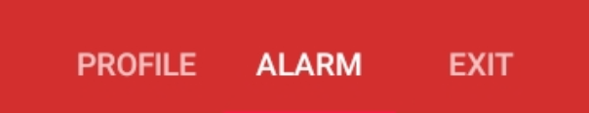

2 : The "Status update function" screen is displayed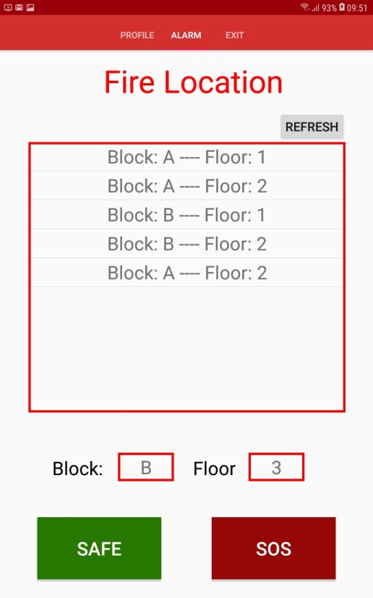 :

3 : Update personal location :

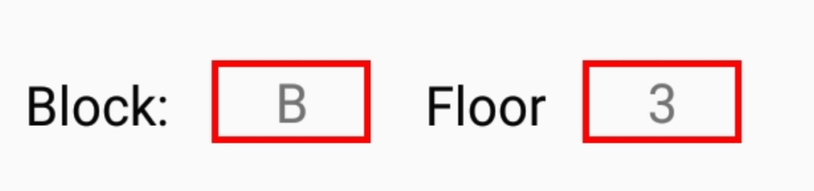 Update personal location

4 : Select Safe (status updates are safe). Select SOS (status update is in danger):



1. See status of loved one upon receiving fire notification

* Description
* Each user can view the status and location of his relatives at the time of receiving the fire notification.
* Stimulus/Response Sequences:

1: Select Tab Profile:

 2: The Profile screen will be displayed:

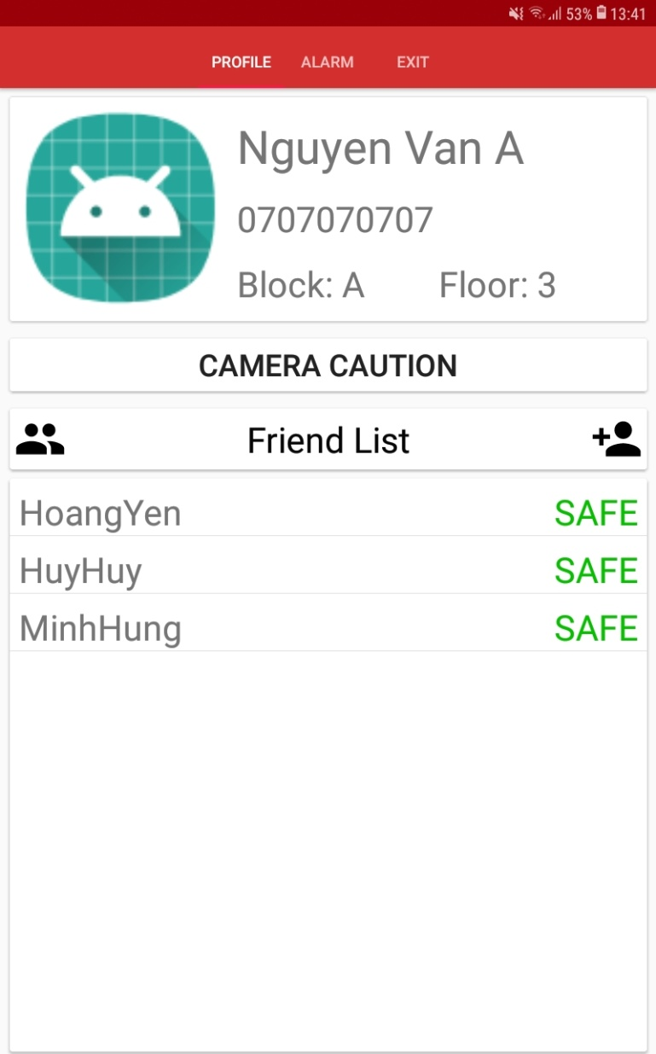

status: safe